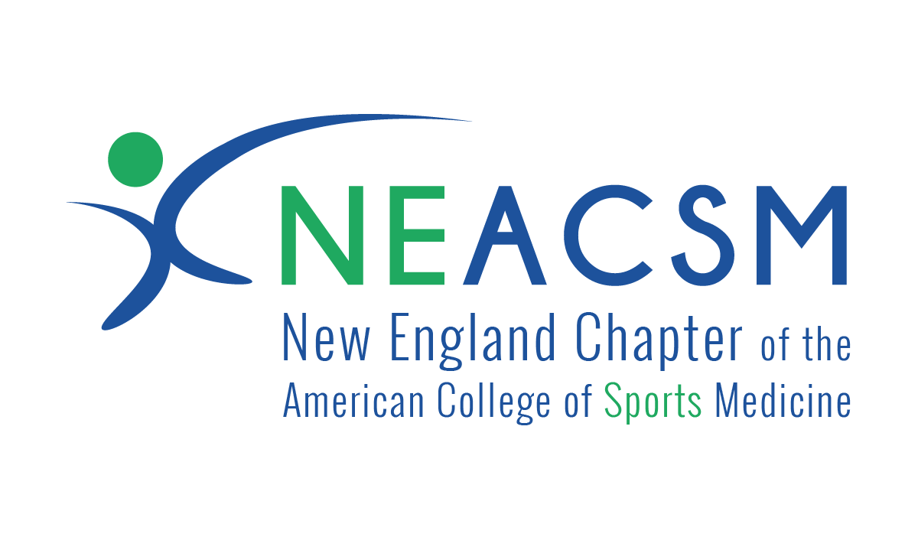

Virtual Sponsorship Opportunities
2020-2021

An Introduction to the NEACSM:

The New England chapter of the American College of Sports Medicine (NEACSM) is one of twelve regional chapters of the American College of Sports Medicine. We represent Connecticut, Maine, Massachusetts, New Hampshire, Rhode Island, and Vermont. The Chapter maintains a strong membership with more than 1,500 members consisting of researchers, educators, exercise practitioners, physicians, allied health professionals, and students (undergraduate, graduate and doctoral).

The NEACSM chapter conducts and assists with many public and professional programs and provides a member forum for public and professional use. The Chapter publishes its own newsletter: the MAX!, which serves to update its members on current events associated with the chapter, as well as recognize sponsors and partners of our conferences and events. Our newly revised website also displays all sponsor logos year-round and has a built-sponsorship page that lists all sponsors for the entire year. With the use of social media platforms, sponsors will be recognized several times throughout the year.

We host two major annual conferences: Fall (two-day) and Spring (one-day). Our conferences draw regional, national and international talent, and provide attendees with current information concerning all aspects of Exercise Science and Sports Medicine.

NEACSM Mission:
The New England Chapter of the American College of Sports Medicine advances and integrates scientific research to provide educational opportunities and practical applications of exercise science and sports medicine in the New England Region.

NEACSM Goals:
- Provide educational and professional events by hosting and sponsoring annual meetings including symposia, workshops and lectures.
- Provide a forum for dissemination of current information and research concerning all aspects of Exercise Science and Sports Medicine to professionals and the public.
- Sponsor lectures and bring regional, national and international researchers in Exercise Science and Sports Medicine to New England.
- Promote and advance medical, educational, and scientific studies dealing with the effects of sports and physical activity on the health of a variety of populations including the apparently healthy and those with known disease.
- Cooperate and share knowledge with other professional organizations, physicians, nutritionists, educators, scientists, exercise practitioners, athletic trainers, physical therapists and allied health professionals who have the same or related specialties.
- Introduce students to ACSM by involving graduate students in regional committee projects and responsibilities and by promoting graduate student research.

NEACSM Sponsorship Levels and Recognition/Benefits

The NEACSM offers many opportunities for sponsorship. These opportunities provide significant exposure to help market organizations products and services within and beyond the NEACSM chapter. The following tables highlight all the benefits of sponsorship.

FALL 2-Day VIRTUAL Conference Benefits
Benefit | Conference Partner  $1000 | Keynote  Sponsor  $750 | Live Session Sponsor  $750 | Invited Speaker  Sponsor  $500 | General Session Sponsor  $300
Logo on Introduction Slide and Verbal Acknowledgement of Sponsored Session(s)

Social Media Acknowledgement on NEACSM Facebook, Instagram and Twitter pages

Conference Registration for Two Persons which gives access to all presentations and discussions

Logo and Sponsor Weblink on NEACSM Website organized by Giving Tier

Logo in Conference Brochure in the NEACSM MAX! Newsletter organized by Giving Tier

