2021 ACSM CEC Certificate
____________ ____________

Participant Name

New England Chapter of the American College of Sports Medicine
Organization

"Progress in Motion”

Course Title

October 21 and 22, 2021

Rhode Island Convention Center, Providence, RI
Date and Location

650388 13.5
Approved Provider Number CECs Awarded

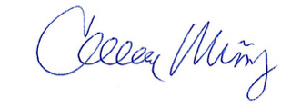
Colleen Muñoz, PhD
Program Chairperson

